**Exercise 6: Library Management System**

**Scenario:**

You are developing a library management system where users can search for books by title or author.

**Steps:**

1. **Understand Search Algorithms:**
   * Explain linear search and binary search algorithms.
2. **Setup:**
   * Create a class **Book** with attributes like **bookId**, **title**, and **author**.
3. **Implementation:**
   * Implement linear search to find books by title.
   * Implement binary search to find books by title (assuming the list is sorted).
4. **Analysis:**
   * Compare the time complexity of linear and binary search.
   * Discuss when to use each algorithm based on the data set size and order.

**Solution:**

**1. Understand Search Algorithms**

Linear Search

* Checks each element one by one.
* Works on unsorted or sorted data.
* Time Complexity:
  + Best: O(1)
  + Average/Worst: O(n)

**Binary Search**

* Works only on sorted data.
* Repeatedly divides the array in half to find the element.
* Time Complexity:
  + Best: O(1)
  + Average/Worst: O(log n)

**2. Setup: Book Class:**

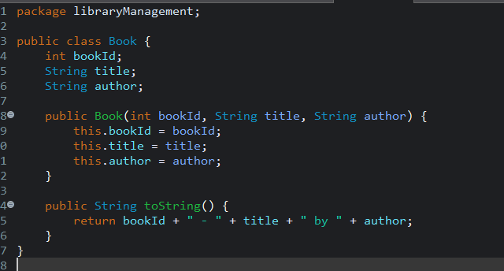

**3. Implementation**

**> Linear Search by Title**

**>** **Binary Search by Title (Requires Sorted List)**

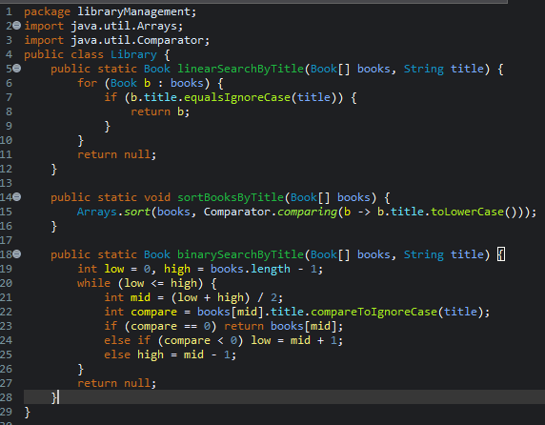

**Main Method to Test Both Searches:**

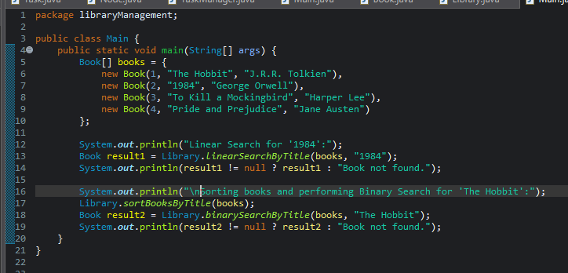

**Output:**

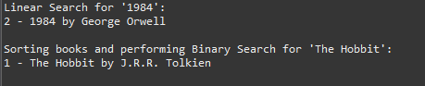

**4. Analysis**

**Time Complexity Comparison**

| **Algorithm** | **Best Case** | **Average Case** | **Worst Case** |
| --- | --- | --- | --- |
| **Linear Search** | O(1) | O(n) | O(n) |
| **Binary Search** | O(1) | O(log n) | O(log n) |

**When to Use Which Algorithm**

| **Situation** | **Recommended Algorithm** |
| --- | --- |
| Unsorted book list | Linear Search |
| Sorted book list (by title) | Binary Search |
| Small dataset (few books) | Linear Search (simple) |
| **Large dataset (frequently searched)** | **Binary Search** |